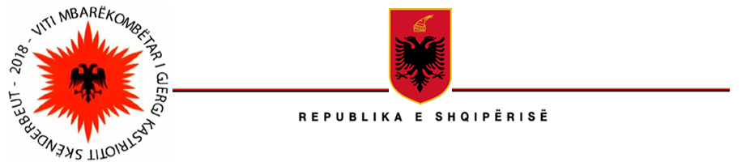

MINISTRIA E INFRASTRUKTURËS DHE ENERGJISË
“HEKURUDHA SHQIPTARE” SH. A

Datë, më 09.08.2022

Lënda: Kthim përgjigje
Drejtuar: z.__________ __________

Dear Mr.!
Thank you for your interest!
I reviewed your request and let me inform you that the railway segment "Durres-Elabasan" is operational. You can see the schedules on our official website. Trust me, you will have a fantastic trip with a beautiful landscape. Thank you for coming to Albania! Our country has a lot to offer our German friends.
Thank you!

Domeniko Sinjari,
Coordination of the right to information

